Project Executable Files

Date | 03 October 2026
Team ID | SWTID-2026-7684
Project Name | PocketSmart AI – Smart Budget & Recommendation Assistant
Maximum Marks | 3 Marks

Project Executable Files
This section requires submission of all executable and deployable files for your project. Ensure all files are properly organized, named, and uploaded to the specified submission platform. The evaluator must be able to run or deploy your solution using the provided files and instructions.

Step 1: Submission Checklist

S.No | Item to Submit | Submitted (Yes / No / NA)
1 | Complete source code (all files and folders) | Yes
2 | README / Setup Guide (instructions to run the project) | Yes
3 | requirements.txt / package.json / dependency file | Yes
4 | Database schema / seed files (if applicable) | Optional – database is created by SQLAlchemy
5 | Environment configuration file (.env.example or similar) | Yes
6 | Deployed application URL (if hosted) | No – local project
7 | APK / Executable binary (if applicable for mobile/desktop apps) | NA
8 | Dockerfile / Containerization config (if applicable) | NA
9 | Test files and test results | Not included
10 | Demo video or walkthrough (if required) | Add if required

Step 2: File / Folder Structure
Provide an overview of your project's file and folder structure below:
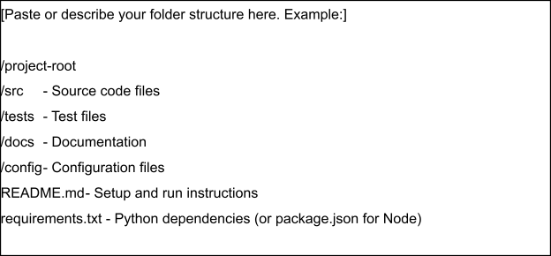

Step 3: Deployment / Access Details

Field | Details
Hosted / Deployed URL | Not currently hosted; run locally.
Login Credentials (Demo) | Create a demo account during evaluation; do not store real passwords here.
Platform / Hosting Provider | Local development: Flask backend + Vite frontend.
Repository Link | Add GitHub repository link here.
Demo Video Link | Yes

Step 4: Run Instructions
Provide clear, step-by-step instructions for the evaluator to run your project locally:
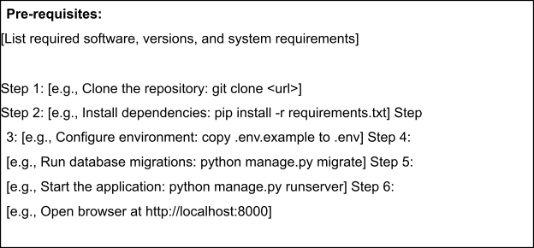

Step 5: Known Issues / Limitations

S.No | Known Issue / Limitation | Workaround / Status
1 | Gemini features require a valid GEMINI_API_KEY and internet access. | Add the key to backend/.env.
2 | SQLite is intended as a local fallback. | Use PostgreSQL for larger deployment.
3 | Automated testing is limited. | Add unit/API tests in future.

